Experiment No 2: Vulnerability Scanning technique using NESSUS.

NESSUS installation Steps

administrator@ubuntu:~$ sudo dpkg -i Downloads/Nessus-5.0.1-ubuntu1110_amd64.deb[sudo] password for administrator:
dpkg: error processing Downloads/Nessus-5.0.1-ubuntu1110_amd64.deb (--install):
cannot access archive: No such file or directory
Errors were encountered while processing:
Downloads/Nessus-5.0.1-ubuntu1110_amd64.deb
administrator@ubuntu:~$ sudo apt-get clean
administrator@ubuntu:~$ cd /var/lib/apt
administrator@ubuntu:/var/lib/apt$ sudo dpkg -i Downloads/Nessus-5.0.2-ubuntu1110_i386.deb
dpkg: error processing Downloads/Nessus-5.0.2-ubuntu1110_i386.deb (--install):
cannot access archive: No such file or directory
Errors were encountered while processing:
Downloads/Nessus-5.0.2-ubuntu1110_i386.deb
administrator@ubuntu:/var/lib/apt$ cd
administrator@ubuntu:~$ sudo dpkg -i Downloads/Nessus-5.0.2-ubuntu1110_i386.deb
Selecting previously unselected package nessus.
(Reading database ... 140541 files and directories currently installed.)
Unpacking nessus (from .../Nessus-5.0.2-ubuntu1110_i386.deb) ...
Setting up nessus (5.0.2) ...
nessusd (Nessus) 5.0.2 [build R23205] for Linux
(C) 1998 - 2012 Tenable Network Security, Inc.

Processing the Nessus plugins...
[##################################################]

All plugins loaded

- You can start nessusd by typing /etc/init.d/nessusd start
- Then go to https://ubuntu:8834/ to configure your scanner

Processing triggers for ureadahead ...
ureadahead will be reprofiled on next reboot
administrator@ubuntu:~$ cd /etc/init.d/nessusd start
bash: cd: /etc/init.d/nessusd: Not a directory
administrator@ubuntu:~$ sudo /etc/init.d/nessusd start
$Starting Nessus : .

Once installation is done go in the browser and type-
https://localhost:8834/register

Login For Nessus:

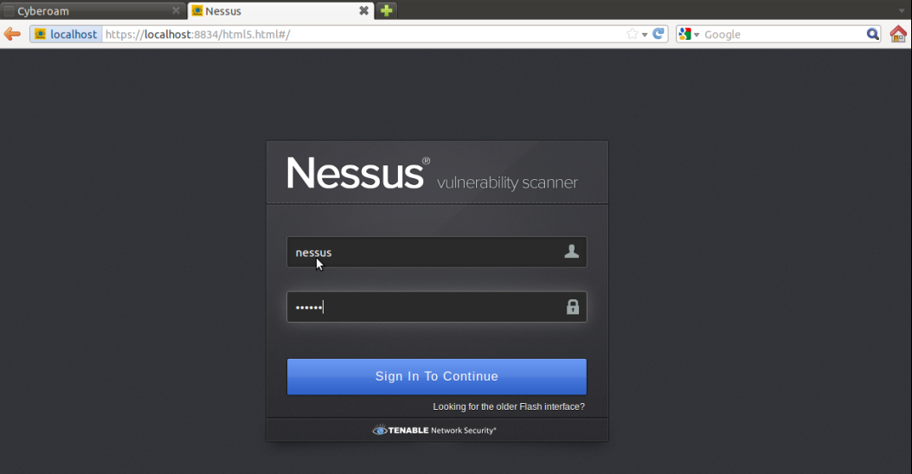

List of User:

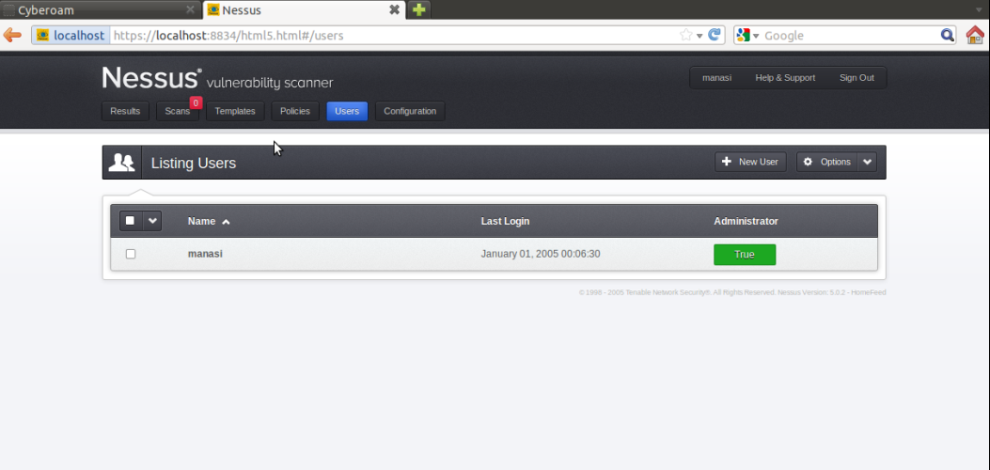

New Scan:

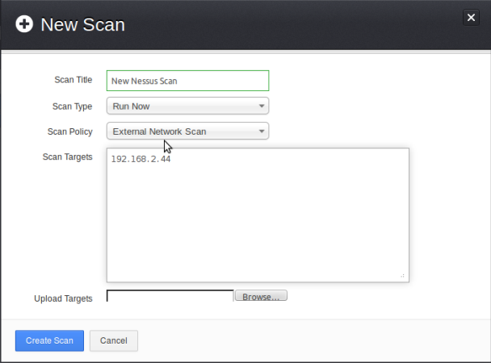

Scan Result:

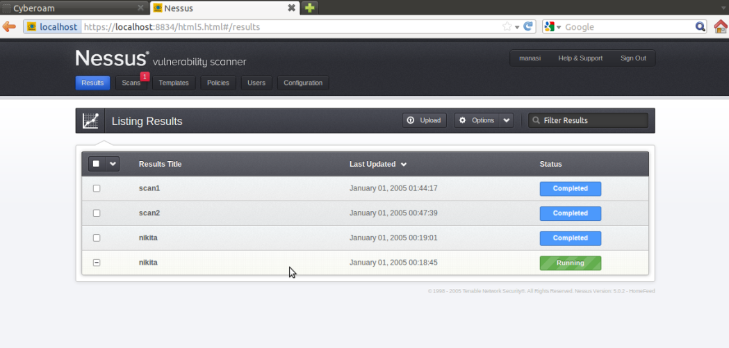

Export Scan Report:

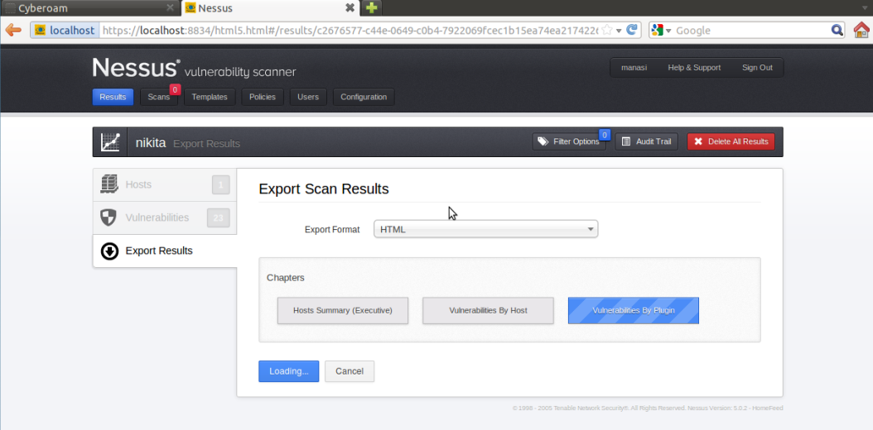

Host Summary:

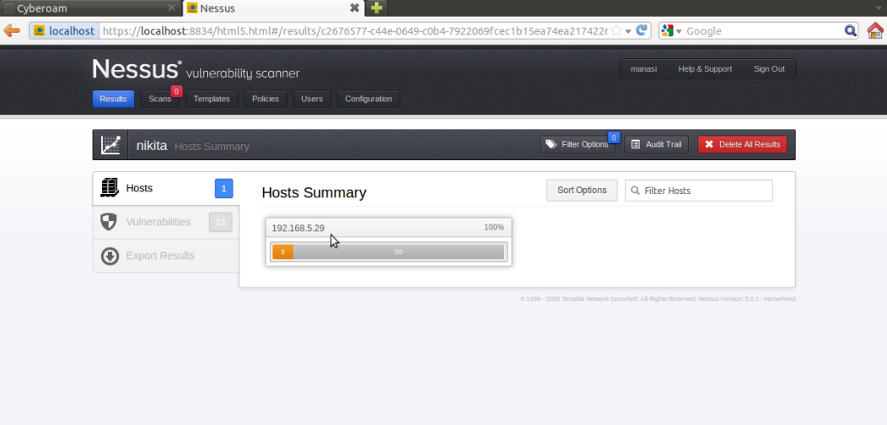

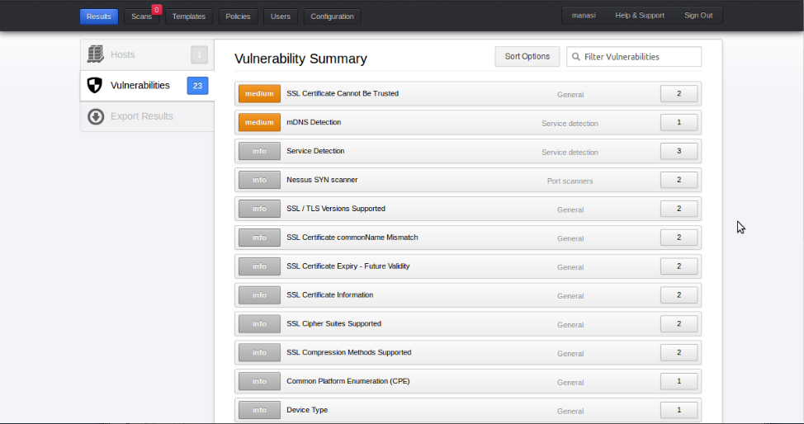

DNS server

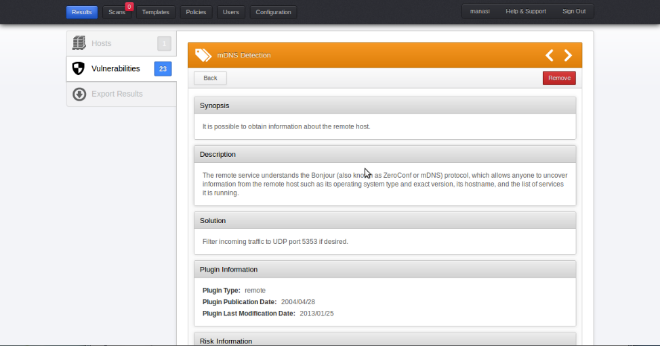

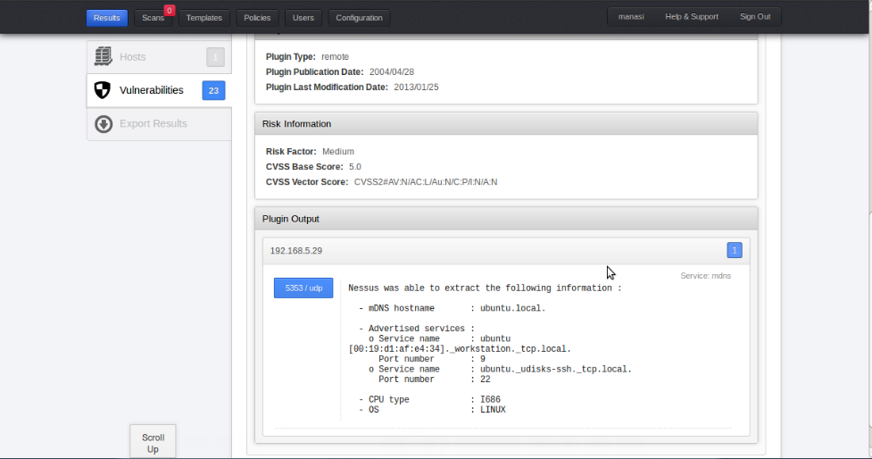

SSL certificate

